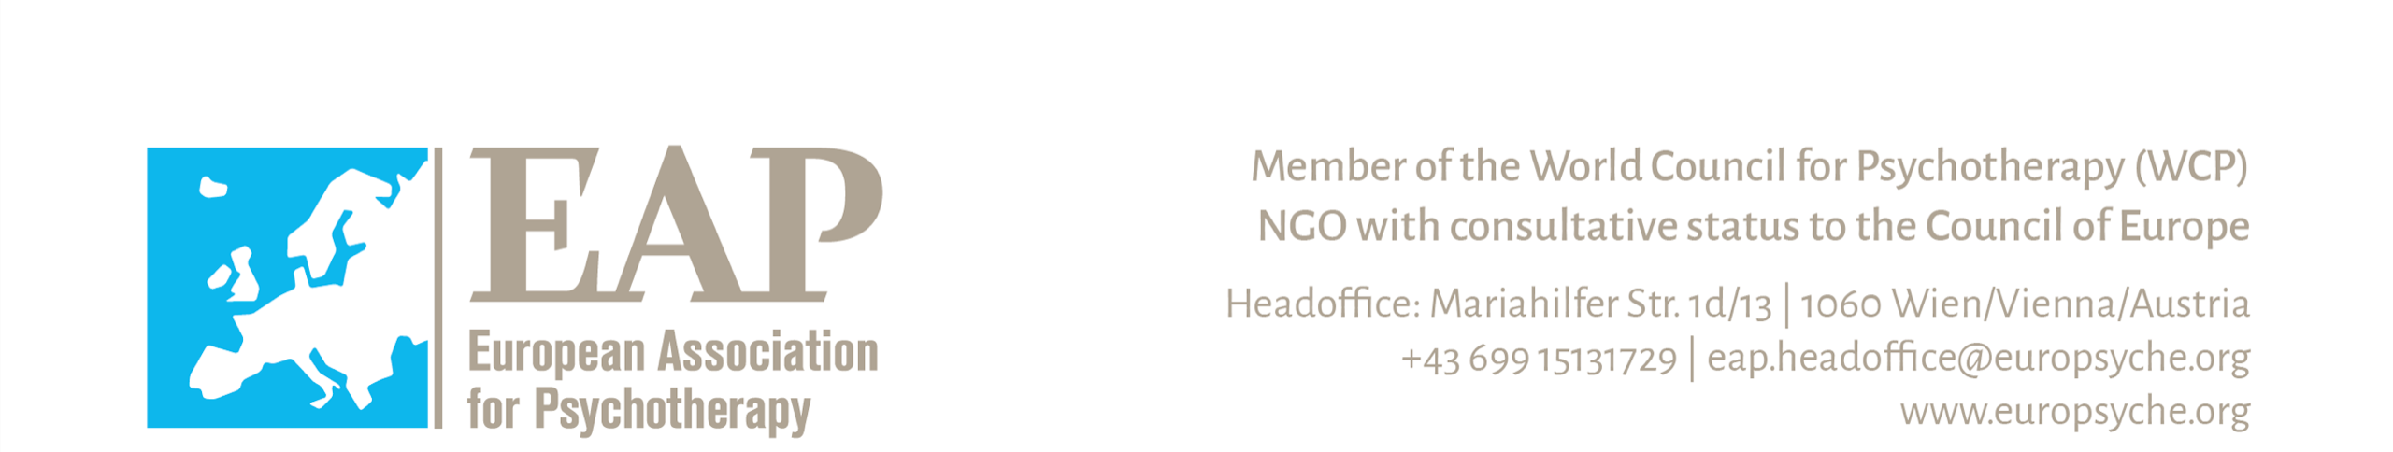

European Association for Psychotherapy
Practitioner Registration Form for European Certificate of Psychotherapy
Please complete every question. Information will be made available to enquirers. Version Feb 2017 / 2019

1) Last Name:
2) Any other last names under which you have been previously registered as
an ECP holder:………………………………………………………………..
3) First Name(s):
4) Abbreviated Title(s) to write on the certificate (Dr., Prof., etc.):
Place photo here
5) ο Female ο Male 6) Date of birth: .......... / .......... / ..........
(Day) (Month) (Year)
The following address will be published in the European Register of ECP Holders:
7) Professional address:
for clients Street: …………………………………………………………………………………….
City: …………………………………………………………………………………….
Country: ………………………………………………. Postal code: …………………….
Phone No.: ……………………………………………………………………………….
Fax No.: …………………………………………………………………………………..
Email address: ……………………………………………………………………………
Home page: ……………………………………………………………………………….

8) Other address: Street: ………………………………………………………………………………….....
City: ………………………………………………………………………………….....
Country: ........................................................................ Postal code: ..................................
Phone No.: …………………………………………………………………………….......
Fax No.: …………………………………………………………………………………...
Email address: …………………………………………………………………………......
Home page: ………………………………………………………………………………..
9) Which address should be your mailing address? ο professional address ο other address

10) If you received the ECP as a result of graduation from an accredited training institute (EAPTI), what is the name of that institute? ........................................................................................................................................................
11) If you receive ECP through grandparenting procedure, name National Awarding Organisation (NAO) which recommended you for the ECP through grandparenting ..............................................................................................
12) In which country are you currently practicing? ...................................................................................................
13) Which NAO currently registers you and would be the relevant country to deal with complaints or disciplinary matters in which you are involved?………………………………………………………........................................
If this is not the NAO of the country specified in (11) please explain why ……………..................................…… ...................………………………………………….………………………………………………………………
14) - If you receive ECP through grandparenting procedure, write here any modality or modalities of psychotherapy that appear under your name in the register of the NAO specified in: .............................................................................
- If you receive ECP through EAPTI (“Direct award”), name modality of EAPTI institute you were trained in:
......................................................................................................................................................................................

15) Which EWAO currently registers you and would be the relevant modality to deal with any complaints or disciplinary matters in which you are involved?……………………………………………………….........................
If this is not the EWAO of the modality specified in (14) please explain why. ………….................................……… .....................……………………………………………………………………………………………….....…………
16) Native language: ......................................... 17) Other languages spoken: .......................................
18) Do your practice premises have facilities for disabled people? ο Yes ο No
19) Appropriate Continuing Professional Development (CPD) is requested according to the NAO regulations in the countries where you are practicing. EAP recommendation for the content and amount of hours of CPD you will find enclosed as Appendix.

20) The Statement of Ethical Principles of the EAP is available at the EAP web page at the following link: http://www.europsyche.org/contents/13134/statement-of-ethical-principles

I have read and I agree to the Statement of Ethical Principles of the EAP ο Yes ο No

To register in the European Register of ECP Holders (ECP-R) you are requested to pay the fee every 3 years.
I'm aware that I will have to pay an annual fee (50 euros per year for Western countries, and less for Eastern ones) for the maintenance of my name on the European Register of Psychotherapists (ERP) and to support the development of the specific profession of psychotherapy in Europe. By signing this I give permission that the shaded information will be published on the internet.
I have read the above, have provided accurate information and agree to the conditions.
Date:..................................... Signature: .........................................................................

Note: False information may lead to the removal of your name from the Register of ECP holders. Failure to notify the Registrar of the Association of changes of the registered address details given
above may also result in your name being removed.

European Association for Psychotherapy

APPENDIX to the Practitioner Re-Registration Form

for European Certificate of Psychotherapy

Continuing Professional Development (CPD) is required for re-registration for the ECP. You are required to complete an average of 50 hours per annum of CPD (total of 150 hours over a period of the last 3 years). This CPD can be taken in the following forms:
- Advanced or additional professional psychotherapy courses (Please list these, include detail of the provider (institute) and a synopsis of the course, and indicate the number of hours for each course on a separate sheet.)
- Professional supervision for psychotherapy practice/clinical/group work and peer supervision (Please indicate this on a separate sheet with name of supervisor/institute, hours of supervision, and the total of number of hours)
- Psychotherapy conference / symposium attendance (Please list title, date and organisation for each on a separate sheet and indicate number of hours of session time attended in each. Please attach copies of all conference attendance certificates).
- Professional activities in psychotherapy. (Being elected to a Board or a Committee and attending meetings. Please indicate organisation, dates of committee/board meetings, and number of formal hours of each meeting.)
- Participation in extra psychotherapy training as a supervisor/researcher/teacher.

Minimum 150 hours shall consist of no more than 50 hours from any one category.

Pre-certification supervision is done according to the criteria of the training institute. All kinds of post-certification professional supervision is done at the practitioner´s free choice with qualified professional supervisors.

