

EAP NEWSLETTER

AN OCCASIONAL COMMUNICATION FROM THE EUROPEAN ASSOCIATION FOR PSYCHOTHERAPY

December 2012

Thank goodness those days are beyond (most of) us!

The dangers are largely dispelled - but the neurotic anxieties remain. [We have even given some of them a ‘respectable’ diagnosis - “Seasonal Affective Disorder” - which for some means, simply, “I hate the bloody winter!”]

And how do many people respond to these anxieties? By a largely neurosis-driven determination to over-consume, to overcompensate for ‘famine’ by excessive consumerism. Anxiety which has to be discharged - even if the origin is unrecognised or unacknowledged.

But somewhere - between the threats of darkness cold and hunger, and our neurotic defences, there is a quiet place. A place of reflection; a place of real gratitude and of appreciation for the fundamentals of life: affirming relationships, love, safety, good food and drink - and luxuries in which to delight.

So, let’s enjoy the chance to set aside time for our families and our friends, to refresh ourselves and share the richness of life together…..

……whilst still sparing a thought for those for whom winter, Christmas and New Year, mean only emptiness, anxiety and misery.

See you on the other side!

Adrian M. Rhodes,
EAP President.

Dear EAP Psychotherapist,

This edition of the EAP Newsletter, comes with the best wishes of the EAP Board, Executive and staff, for Christmas and the New Year.

We are, perhaps the first generations to be largely insulated from the full force of winter - (though I am of course aware that this does not apply to all). We dispel the darkness by lighting our homes, places of work - even our streets. We defy the cold with central heating and double-glazing; even our cars are well-heated - meaning we can skip from home to work to shops, hardly feeling the force of cold and storms.

Yet for countless millennia - right until a few decades ago, winter was feared - not only for its downright unpleasantness, but because of the real dangers to existence - and our inability to overcome them.

Our only defences were to harbour what supplies of food and fuel we could, to ward off the cold and the darkness. And to draw together in family groups, huddled together in our ‘caves’ for warmth, comfort and protection against the icy storms, ravenous wolves and threat of attack.

European Association for Psychotherapy
Schnirchgasse 9a/4th floor/410, A-1030 Vienna, Austria - www.europsyche.org
December 2012

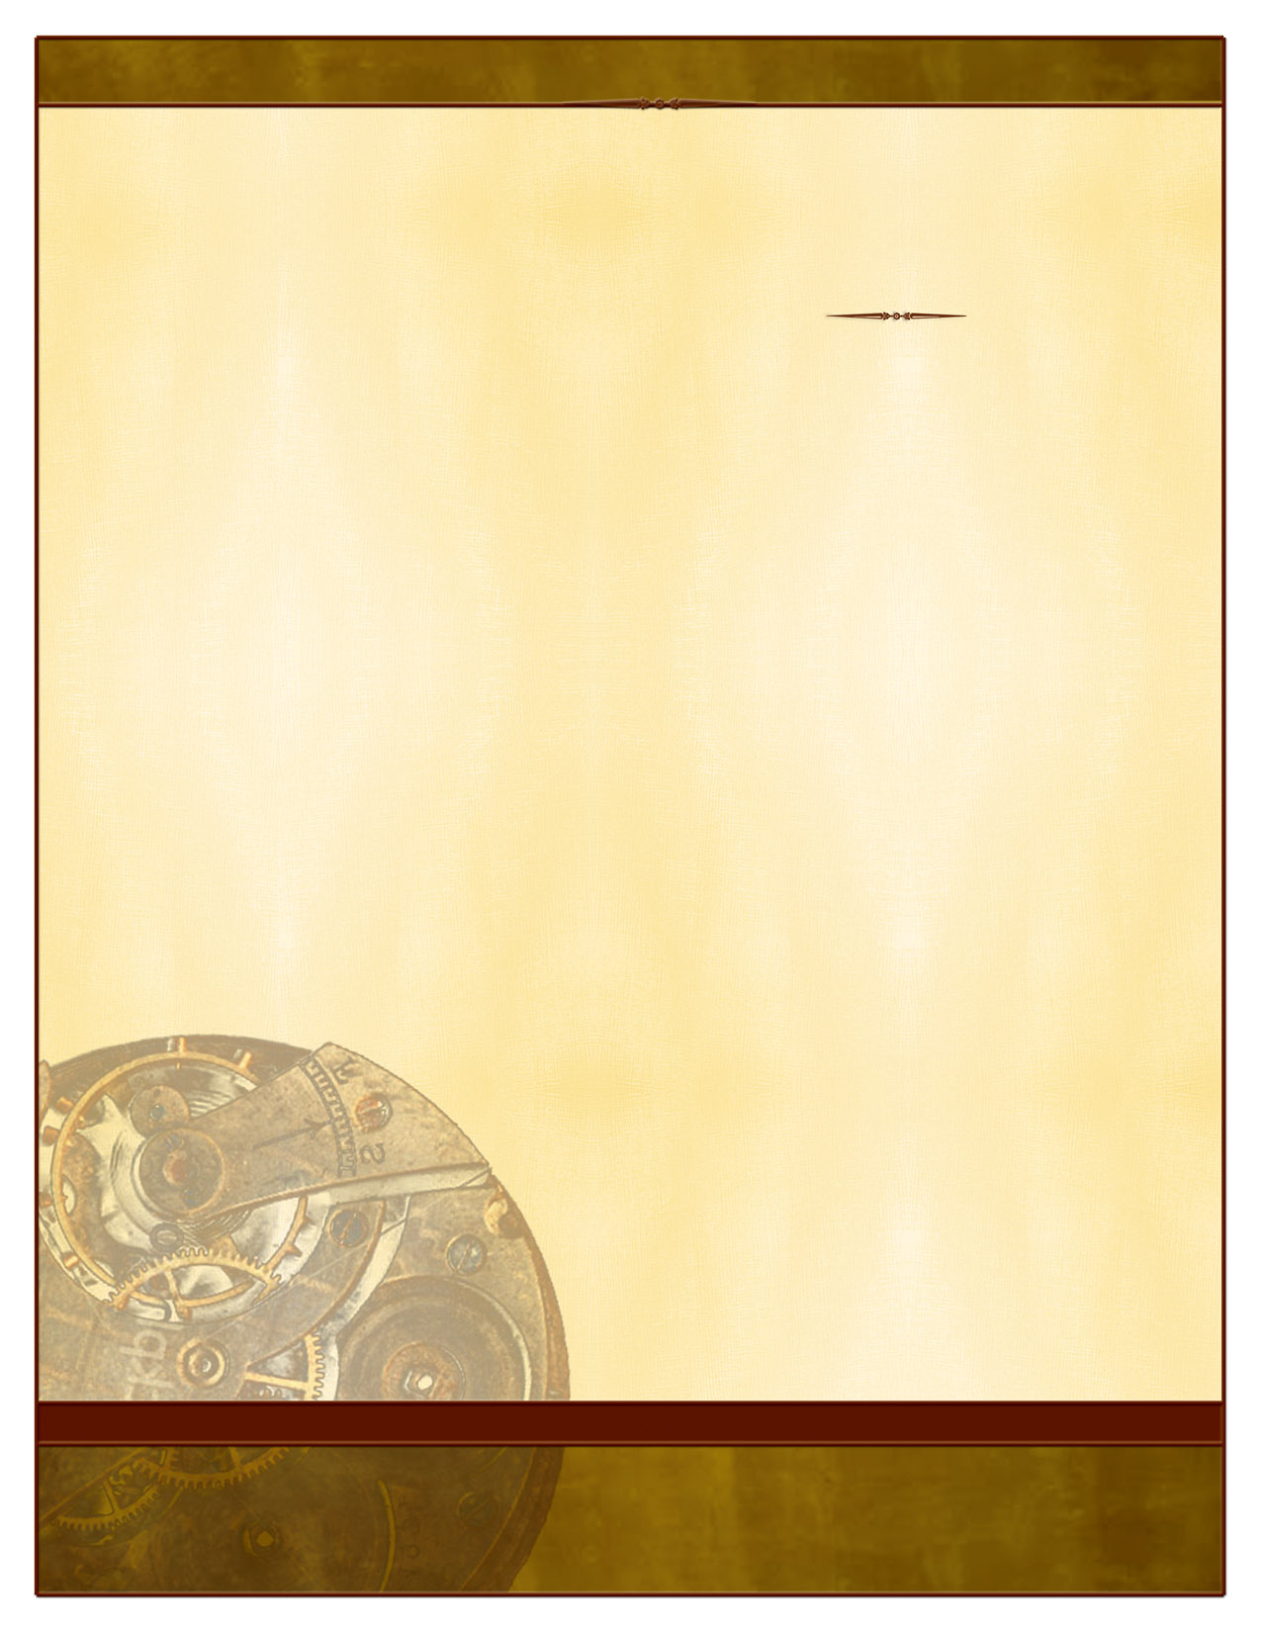
Psychotherapy in Malta
European Association for Psychotherapy
Schnirchgasse 9a/4th floor/410, A-1030 Vienna, Austria - www.europsyche.org

Like in many other European countries, Maltese psychotherapists have been fighting with the legislative bodies to have psychotherapy recognized as a profession independent of psychology and psychiatry. The Maltese Association of Psychotherapists (MAP) has been at the forefront of this battle; lobbying, meeting the relevant regulatory bodies and explaining what psychotherapy is. In 2003, psychotherapy was recognized as one of the professions complementary to medicine. This led to a clear definition of criteria which demarcated psychotherapy from other professions and defined it as an independent profession. A register was later set up where psychotherapists were asked to register, giving the profession more robustness and credibility.

Current issues now involve attempts to convince local government to create psychotherapy as a profession within its ranks. Though presently psychotherapy is recognised as a different profession from clinical psychology and psychiatry, the profession is not yet included in the government structures. Therefore at present there is no psychotherapy department, neither in the educational nor in the health care sectors. The psychotherapy grade and role does not exist and this leaves a vacuum. Many psychotherapists work with government bodies in a number of different roles, ranging from social workers, to nurses and teachers. Some do psychotherapy work under the offices of clinical psychologists and are classified as assistant psychologists with a speciality in psychotherapy. Psychologists within the government battle and resist psychotherapists’ efforts to branch out independently, insisting that they can do psychotherapeutic interventions themselves. Many psychiatrists, on the other hand, are getting trained in psychotherapy theory.

A number of psychotherapists practice in private schools, NGO’s and/or have their own private practice. The latter however is most of the time carried on a part time or casual basis, as only few to date, have managed to create a steady and stable income for themselves on a full time basis.

The great majority of psychotherapists in Malta have been trained in Gestalt psychotherapy. This is due to the simple fact that the first school to provide such training was the Gestalt Psychotherapy Institute Malta (GPTIM) which was founded in 1993 by Dr. Lidija Pecotic. Ever since, over 100 psychotherapists have graduated, with some even specializing in supervision. Some other modalities exist in very small numbers like family therapists and psychoanalysts.

The qualifying criteria to become a psychotherapist are in line with those of EAP. One has to possess a first degree in one of the Humanities and a post-graduate diploma in a psychotherapy modality obtained from a recognised school of psychotherapy. Apart from the theoretical component, personal therapy on an individual and group basis is required. The Maltese Qualifications Recognition and Information Centre (MQRIC) accredits diplomas presented and in case of psychotherapy studies, these have been classified as level 7. This is a Masters equivalent. Only after this approval can psychotherapists apply to be included in the aforementioned registry.

Charles Cassar,
Malta Representative to EAP.
Chair, National Umbrella Organisation Committee


PSYCHOSYNTHESIS PSYCHOTHERAPY

MONTH, YEAR VOL # ISSUE #

Delete box or place a cption here.
Delete box or place a caption here.
Continue newsletter text here. Continue newsletter text here. Continue newsletter text here. Continue newsletter text here. Continue newsletter text here. Continue newsletter text here. Continue newsletter text here. Continue newsletter text here. Continue newsletter text here. Continue newsletter text here. Continue newsletter text here.
Continue newsletter text here. Continue newsletter text here. Continue newsletter text here. Continue newsletter text here. Continue newsletter text here. Continue newsletter text here.
Continue newsletter text here. Continue newsletter text here. Continue newsletter text here. Continue newsletter text here. Continue newsletter text here. Continue newsletter text here. Continue newsletter text here.
Continue newsletter text here. Continue newsletter text here. Continue newsletter text here. Continue newsletter text here. Continue newsletter text here. Continue newsletter text here. Continue newsletter text here. Continue newsletter text here.

HEADLINE
SUBHEAD. SUBHEAD.
SUBHEAD. SUBHEAD.




European Association for Psychotherapy
Schnirchgasse 9a/4th floor/410, A-1030 Vienna, Austria - www.europsyche.org

2) The interaction of Body, Feelings and Mind. Some of Assagioli’s ideas prefigured recent discoveries in neuroscience. His ten laws of interaction between body, emotions, imagination and thought (The Act of Will), at a time when science believed these functions specialized and thus independent of each other, illustrate their overall interdependent functioning as can be now demonstrated by the activation of different parts of the brain.

3) The use of Will and Creative Imagination. Assagioli reintroduced the Will as a trainable vital energy taking different forms, stages and qualities. Also, creative imagination and intuition are used to expand the capacity of the mind to examine personal and professional issues.

4) Meaning and life passages. Throughout the years, psycho-synthesis has been used as an invaluable tool to help people go through personal crises and life passages. Psychosynthesis psychotherapy can help find a larger meaning emerging out of the personal maturation process.

5) Clinical Applications. Psychosynthesis has been applied to a wide variety of fields: psychiatry, cancer treatment, addictions, depression, geriatrics, education, etc. Assagioli used to say : If it comes in time, its education; if it comes too late, its psychotherapy. Psychosynthesis is used by Diana Whitmore in the U.K. in government subsidized programs for at-risk youths and adolescents.

Psychosynthesis is “a process of growth based on the harmonious integration of all aspects of the personality around the self, the center of awareness and will”. (R. Assagioli, The Act of Will, Preface, p. vi).

A specificity of psycho-synthesis psychotherapy is found in the bifocal vision of seeing the client as healthy and whole in a transpersonal context, focusing on a self-fulfilling potential trying to emerge rather than on a pathology. The therapist holds a quality of receptive presence that listens to not only the personality and the interaction of body, mind and emotions, but also the essential qualities of the Self. From the eternal. Out of the past. In the present. For the future. (R. Assagioli).
Like all stories, that of Psychosynthesis starts by a meeting.

In 1909, Jung first met the young Roberto Assagioli who had come for training in the famous Swiss clinic of Burgholzli headed by Bleuler of which Jung was the assistant. Jung wrote at that time to Freud: « Among the migrating birds… our first Italian, a certain Doctor Assagioli, of the psychiatric clinic of Florence. This young man is very intelligent, and seems a very learned man, an enthusiastic adept entering our domain with the necessary brio ».
This is how Roberto Assagioli entered into contact with psychoanalytical circles: he became the first Italian psychoanalyst and the correspondent of the Jahrbuch für Psychoanalytische und Psychopathologische Forschungen, the yearbook of psychoanalysis.
However, soon after, Jung and Assagioli, who had independent minds, started directing their search towards a direction other than Freudian obedience. Jung launched the basis of the individuation process and Assagioli created in 1926 bio-Psychosynthesis. We point out the similarities in their search especially since their authors maintained an epistolary relationship.

What then are the founding principles of Psychosynthesis?

1) The Unconscious and Consciousness. Assagioli placed the Subject, the “I”, in the centre of the psyche, distinct from the contents of the unconscious, bringing a unifying perspective to the entire psyche.

In 1926, he wrote: « Psychosynthesis studies each psychic fact in relation to its vital connection with the centre of consciousness, on the basis of knowledge and the action of the “I”». This “I” is developed through the practice of dis-identification and reflects the energies of the higher Self. The “I” does refer to an expanded experience of oneself, as a multidimensional being, body/mind/emotions/soul, in relation to others and to the world.

MONTH, YEAR VOL # ISSUE #

Delete box or place a cption here.
Delete box or place a caption here.
Continue newsletter text here. Continue newsletter text here. Continue newsletter text here. Continue newsletter text here. Continue newsletter text here. Continue newsletter text here. Continue newsletter text here. Continue newsletter text here. Continue newsletter text here. Continue newsletter text here. Continue newsletter text here.
Continue newsletter text here. Continue newsletter text here. Continue newsletter text here. Continue newsletter text here. Continue newsletter text here. Continue newsletter text here.
Continue newsletter text here. Continue newsletter text here. Continue newsletter text here. Continue newsletter text here. Continue newsletter text here. Continue newsletter text here. Continue newsletter text here.
Continue newsletter text here. Continue newsletter text here. Continue newsletter text here. Continue newsletter text here. Continue newsletter text here. Continue newsletter text here. Continue newsletter text here. Continue newsletter text here.

HEADLINE
SUBHEAD. SUBHEAD.
SUBHEAD. SUBHEAD.

European Association for Psychotherapy
Schnirchgasse 9a/4th floor/410, A-1030 Vienna, Austria - www.europsyche.org

“What am I then?

What remains after discarding from my self-identity the physical, emotional and mental contents of my personality, of my ego? It is the essence of myself – a center of pure self-consciousness and self-realization. It is the permanent factor in the ever varying flow of my personal life. It is that which gives me the sense of being, of permanence, of inner security, … a center of pure self-conscious…, capable of observing, mastering, directing and using all the psychological processes and the physical body.” (R. Assagioli, Psychosynthesis, pp. 104-105).

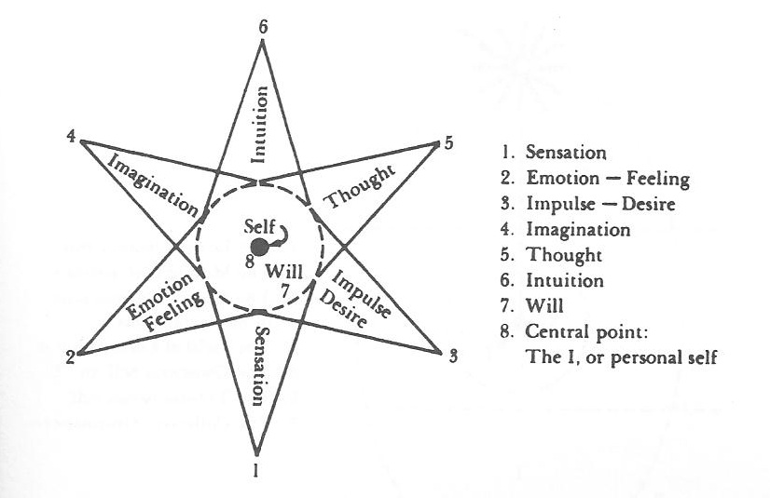

Contacts: Tan NGUYEN, President EFPP, tandante@gmail.com
European Federation for Psychosynthesis Psychotherapy (EFPP), www.psychosynthesis.net
Association for the Advancement of Psychosynthesis (AAP), www.aap-psychosynthesis.org
U.K. - Psychosynthesis & Education Trust (PET), www.psychosynthesis.edu
France - Centre Source, www.psychosynthese.com

Joanne Wilson,

Joanne represents the Centre AEON in Basel in the EAP, and is General Secretary of The European Federation of Psychosynthesis Psychotherapy (EFPP)

Psychosynthesis Psychotherapy Contd.
But “psychosynthesis does not attempt to give a metaphysical nor a theological explanation of the great Mystery – it leads to the door, but stops there.” (R. Assagioli, Psychosynthesis, p.5).

“The conscious and purposeful use of self-identification – or dis-identification – is basic in psychosynthesis. It proceeds from a dynamic center on which the whole process of synthesizing the psychological multiplicity into an organic unit based. We are dominated by everything with which our self is identified. We can dominate and control everything from which we dis-identify ourselves.” (R. Assagioli, Psychosythesis, p. 98).

A basic exercise in dis-identification: “The first step is to affirm... and to become aware of the fact: “I have a body, but I am not my body.” ... something material and changeable, (...within a few years all the cells of the body are renewed). We say “I am tired’, [but] the “I” cannot be tired; the body is tired and transmits to the “I” a sensation of fatigue.”

“[Then] ...the realization: “I have an emotional life, but I am not my emotions or my feelings”, ...psychological states which are changeable and often contradictory. To say “I am irritated, ...content, ...dissatisfied” is to commit an error of psychological grammar. Let us say instead: “There is in me a state of irritation.”

“The third step consists in realizing: “I have an intellect, but I am not that intellect.” When we analyze [our thoughts], when we observe ourselves while we think, ... we can look at the logical or illogical connections, at the working of the mind, observing it from above.... This indicates that we are not our thoughts.”

MONTH, YEAR VOL # ISSUE #

Delete box or place a tag line or quote here. Delete box or place a tag line or quote here.
Delete box or place a tag line or quote here.

PSYCHOTHERAPISTS' DREAMING:
What are the psychotherapists dreaming of?
Snezana Milenkovic, Ph.D. professor
Jelena Sakotic-Kurbalija, Ph.D. assistant professor
University of Novi Sad, Faculty of Philosophy, Department of Psychology, Serbia

What do our wishes look like - regarding our personal wellbeing, profession and our clients, as well as the wellbeing of humankind generally?
This is the central question on which my associate, Jelena Sakotić-Kurbalija and I focus on in this research we have done in 2011.

The hypothesis from which we started was that most psychotherapists would 'dream' about their personal wellbeing, that a smaller number of them would bear in mind professional wellbeing and the wellbeing of their clients, and that the fewest psychotherapists would long for the humankind wellbeing.

The sample included European certified therapists of various modalities (Integrative - 9 subjects; Systemic Family Therapy - 6 subjects; KBT - 1; REBT – 2; Body Therapy – 3; Gestalt Therapy – 3; Psychodrama – 3; TA - 2; Psychoanalitic – 2; Existential – 1; Client Centered Therapy – 1; Psychosynthesis – 1; NLP- 1 subject).
Since this is the exploratory research, the sample has been chosen respectively.

The majority of the examined psychotherapists have the European Certificate for Psychotherapy (74.29%), while only one fourth have the National Certificate (25.71%). As no significant statistical difference has been established between these sub-samples (groups), in the further processing of the data these variables have been examined as the same sample – from the population of the certified therapists.
The number of female therapists included in the sample was twice as large as that of male therapists (68.57 : 31.43%), which also corresponds to the ratio in the population of the psychotherapists.
According to the gender of the questioned therapists, there were no statistically significant variables; therefore in the subsequent processing of the data, they were examined as the same sample.

All the examined psychotherapists are older than the age of 30, and only one respondent is older than the age of 70. Almost half of the questioned respondents is between the ages of 30-50, and more than a half of them are older than the age of 50.
40% of the questioned psychotherapists have less than 10 years of psychotherapeutic experience and 60% of the respondents have more than 10 years of the psychotherapeutic experience, out of which 31. 43% of the questioned psychotherapists had more than 20 years of professional experience. Variables between sub-samples of no statistical importance.

Method: A specially designed questionnaire was used, consisting of a number of questions, the main one being: What do psychotherapists dream of, personally and professionally? There were two more questions significant for monitoring the assumed level of development among psychotherapists; these pertained to the importance of spirituality in the lives and work psychotherapists.

Spirituality (as differentiated from religiousness) was defined as the process by which human beings transcend themselves, concrete, finite particulars of the world. It takes place within the framework of their ideals and aspirations. It takes them beyond themselves to the realm they can experience a union with something larger than themselves, and in that union finds their greatest peace. This definition was offered to the subjects in explanation of the questions related to spirituality.

Independent variables included: gender, age, years of psychotherapeutic experience and the certification levels.
Dependable variables included: the subjects' answers to the question: What do psychotherapists dream about, and ranking the importance of the spirituality in relation to the foremost life achievements.

European Association for Psychotherapy
Schnirchgasse 9a/4th floor/410, A-1030 Vienna, Austria - www.europsyche.org

Delete box or place a tag line or quote here. Delete box or place a tag line or quote here.
Delete box or place a tag line or quote here.

Collected data were processed by content analysis and chi-square test; the answers to the following questions were analyzed:
- What is their dream (professionally, as psychotherapists; and as private individuals)?
- What is the level of importance of spirituality, as one of the foremost life achievements, on the 1-5 scale?
- Is the spiritual side of life important?

Survey results
All the questioned psychotherapists dream about:

personal well-being (the most common answers: family and children wellbeing; good health; traveling; personal love, happiness, peacefulness, harmony, fun, and alike; self-development; good partner’s relationship; money issue; friendship; nature; to be at leisure; to have a hobby; etc.),;

professional development – wellbeing (the most common answers: psychotherapy to become an independent profession; to integrate theory and practice; to confirm theoretical concepts through research; to make better integration between modalities; to ground institutions for psychological development - growth
centers; to make available psychotherapy to wider population; to broaden the scope of interest for psychotherapy; to develop themselves to be better psychotherapists);

client’s wellbeing ( the most common answers: to be of use to their clients who need to be helped; to help numerous beneficiaries; not only to help but to keep joyful encounter with the clients and to promote the psychotherapy seen as a challenge; to develop together with their clients; to help marginalized groups of people);

But only 5 questioned psychotherapists (1/7 of all) ’dream’ and wish the wellbeing of the humankind, (the most common answers being: wellbeing for all human beings; kindness among people; deep connection with people and support for their growth; preservation of God-made gifts to the planet, less violence and more respect and consideration; care for earth, our mother, a more just and equitable world; peace on earth).

PSYCHOTHERAPISTS' DREAMING (Contd)

Conclusion

Our inner transformation begins with personal analysis - 'working on ourselves' - releasing us from the burden of our past which involves our self-discipline of gradually replacing our ‘negative conditioning’ and widening the scope of our self-consciousness corresponding with ‘positive conditioning’.

So we can reach the psychological maturity, and then go further towards spiritual
maturity (transcending our ego) - to be able to help other human beings, not only our clients, but to be emphatic and solidarity with all humankind. Starting with a wish for good things for ourselves we then take that natural feeling towards ourselves and cultivate it, enhance it; and extend it to include and embrace others - all humankind.

Considering the survey results it seems obvious that all psychotherapists are concerned with their personal wellbeing, less with their professional and the least with the humankind wellbeing.

Keywords: psychotherapist, values, personal wellbeing, professional wellbeing, client's wellbeing, humankind wellbeing

Snezana Milenkovic is Chair of the EAP Research Committee.

It is intended to bring interesting Research articles to each edition of the newsletter

European Association for Psychotherapy
Schnirchgasse 9a/4th floor/410, A-1030 Vienna, Austria - www.europsyche.org

